**ERD Model PART 3**

Illustrate that you understand normalization and how to use it to reduce uncontrolled redundancy in your database design by creating two ERD diagrams:

**Answer:** Normalization has been used in this database system in order to decline the redundancy of data values. It has effectively applied to give structure to the different data values and eliminate the duplicate values whenever found in the dataset. Subsequently, a large dataset can be divided into smaller tables that sequentially helped an analyst to develop an ERD diagram.

Create the first using UML and the Umlet free utility.

**Answer:**

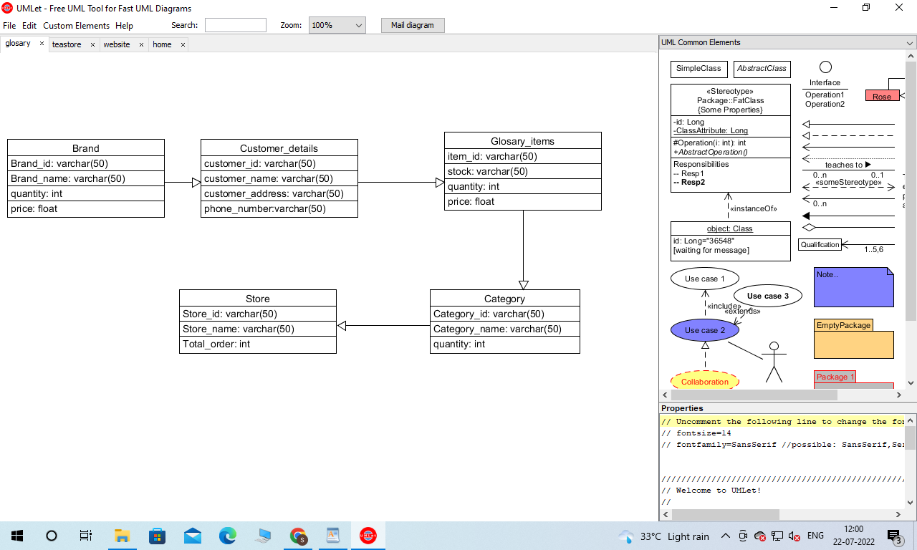

Create the second using Crow’s Foot notation in Vertabelo.

**Answer:**

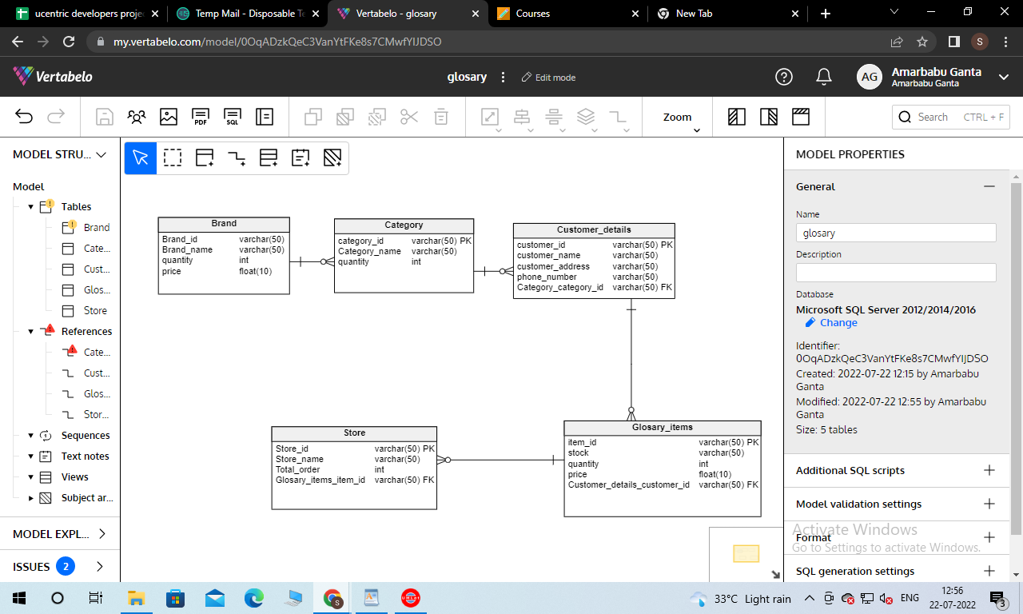

**Description of Entity Relationship Diagram:**

For the business purpose above we create an entity relationship diagram. For the entity relationship diagram we can easily create our database and know information about the data of each entity. For the five entity we create five entity relationships. our first entity which has one to many relationship with the brand entity and category entity. There we create one to many relationships between category entity and customer_details Entity. There is one to many relationship between the customer_details entity with glossary_items. A glossary entity also has a store entity which is one to many relationships.

Here in this project there are many Entity relationships which helps to to create a business database. Here we describe all the entities which help to develop this database for our business model.This is how we can get access data from the database through the queries.